|  |  |  |  |
| --- | --- | --- | --- |
| **BAHRIA UNIVERSITY,** | | | |
| **(Karachi Campus)** | | | |
| *Department of Software Engineering* | | | |
| **ASSIGNMENT #. 03 – Spring 2022** | | | |
| COURSE TITLE: **Operating Systems** | | COURSE CODE: **CSC-320** | |
| Class: | **BSE - 4(A & B)** | Shift: | **Morning** |
| Course Instructor: **Engr. Rizwan Fazal** | | Date: | **20-June-2022** |
| Due Date: | **30-June-2022 (4pm)** | Max. Marks: | **10 Points** |

## Instructions:

1. **This is an individual effort task.**

## Only handwritten answers are accepted on A4 size papers

1. **Write your full name, registration number and section on the title page attached with this assignment. (Assignment WITHOUT title page will NOT be accepted!)**

## The given deadline is final and will not be extended in any case, therefore, it is highly recommended to start it as soon as possible

**[CLO-5]**

**Q.** Refer to the following diagram, illustrating the feedback scheduling mechanism by showing the path that a process will follow through the various queues. This approach is known as Multilevel Feedback, meaning the OS allocates the processor to a process and when the process blocks or is preempted, feeds it back into one of several priority queues.

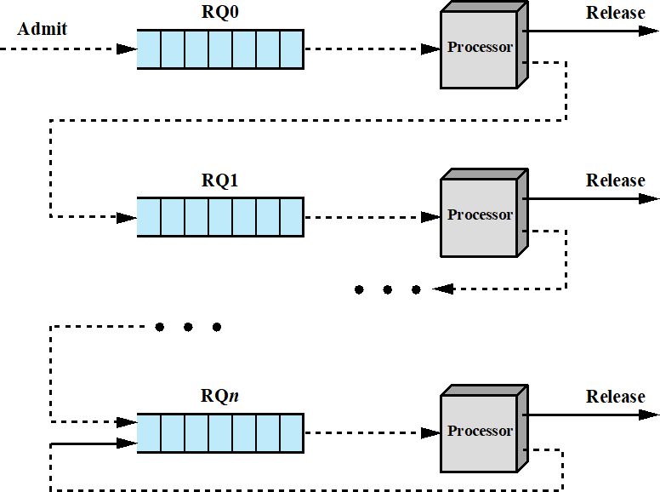

Suppose we have three processes A, B and C that arrive in the system having estimated burst times of 100 ms, 120 ms and 60 ms respectively.

Investigate the performance of the above given system for the following case if there are only *3 Ready Queues* namely RQ0, RQ1 and RQ2:

(1). Round Robin in every queue with the relation **q = (2i x 10) ms,** where ‘i’ is the Queue number starting from 0 to 2 as there are only 3 queues in this system. It means that each subsequent queue will have greater time quantum.

## Tasks:

(1). Draw a neat and clean diagram showing the execution progress of each process on a time scale of **q = (2i x 10) ms**

(2). Calculate the Turnaround time and Normalized Turnaround around time for each process according to the following given table:

|  |  |  |  |
| --- | --- | --- | --- |
| **Serial #.** | **Process** | **Turnaround Time** | **Normalized Turnaround Time** |
| 1 | A |  |  |
| 2 | B |  |  |
| 3 | C |  |  |

1. Draw a conclusion based on this study by taking into account the following parameters:
   * Processes execution time
   * Scheduling technique
   * Turnaround time and normalized turnaround time

## Submission Guidelines:

1. Remember that, you will not be able to solve the above given problem until unless you properly understand the relevant concepts discussed during classroom lectures.
2. Prepare your solution on A4 size papers (paper with horizontal lines preferred) and must be neat and clean.
3. You are not supposed to share your assignment with others, otherwise it will be cancelled.
4. You can discuss the subject matter with each other but when it comes to problem solution, it shouldn’t be copy pasted.

|  |  |  |  |
| --- | --- | --- | --- |
| **BAHRIA UNIVERSITY,** | | | |
| **(Karachi Campus)** | | | |
| *Department of Software Engineering* | | | |
| **ASSIGNMENT #. 03 – Spring 2022** | | | |
| COURSE TITLE: **Operating Systems** | | COURSE CODE: **CSC-320** | |
| Class: | **BSE - 4(A & B)** | Shift: | **Morning** |
| Course Instructor: **Engr. Rizwan Fazal** | | Date: | **20-June-2022** |
| Due Date: | **30-June-2022 (4pm)** | Max. Marks: | **10 Points** |

**ASSIGNMENT #. 3**

**Submitted by:**

# Name: M Muaz Shahzad

Registration #: 02-131202-081

# Section: BSE-4B

